

**IT1130**

**Mathematics for Computing**

**Year 1 – Semester 1**

**Lab Report - 01**

Submitted to

Sri Lanka Institute of Information Technology

In partial fulfillment of the requirements for the

Bachelor of Science Special Honors Degree in Information Technology

<<25/07/2024>>

**Declaration**

I certify that this report does not incorporate without acknowledgement, any material previously submitted for a degree or diploma in any university, and to the best of my knowledge and belief it does not contain any material previously published or written by another person, except where due reference is made in text.

Registration Number: IT24100135

Name: S. Hihturshan

Exercise 1

Q1), Q2)

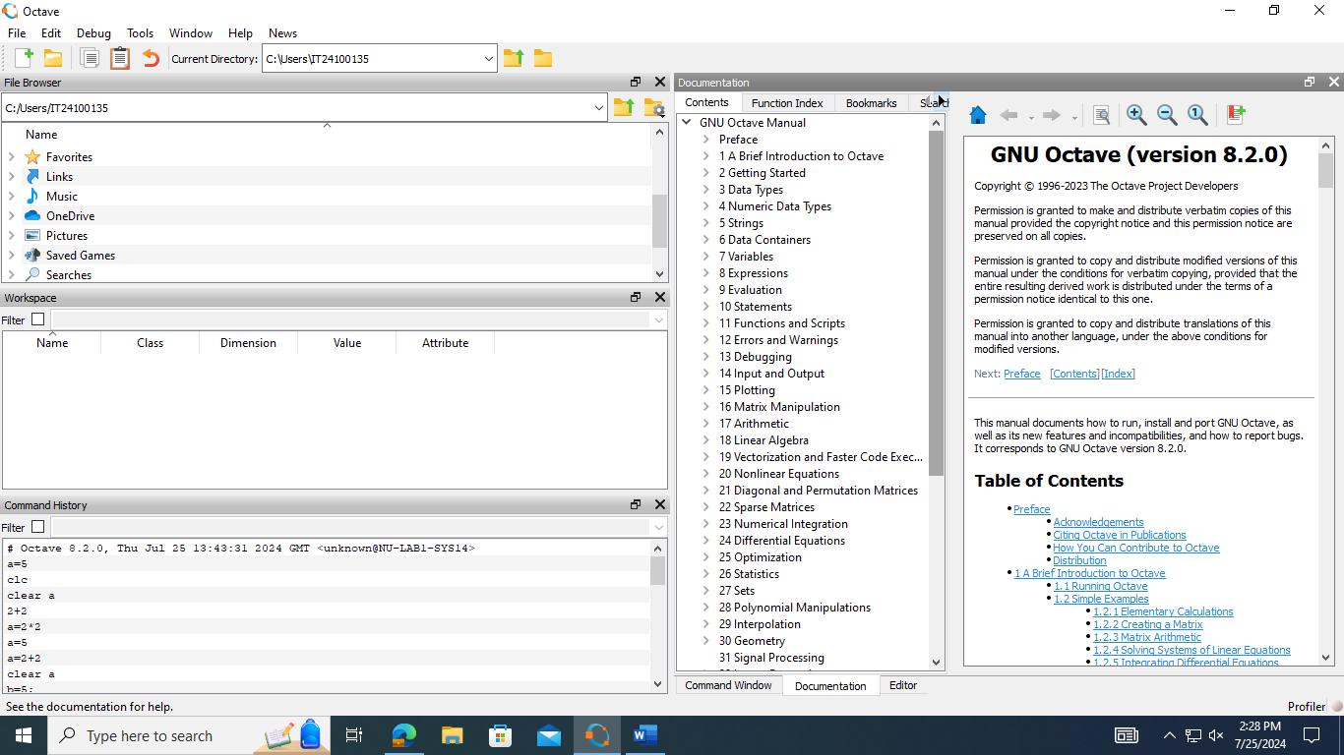

Q3)

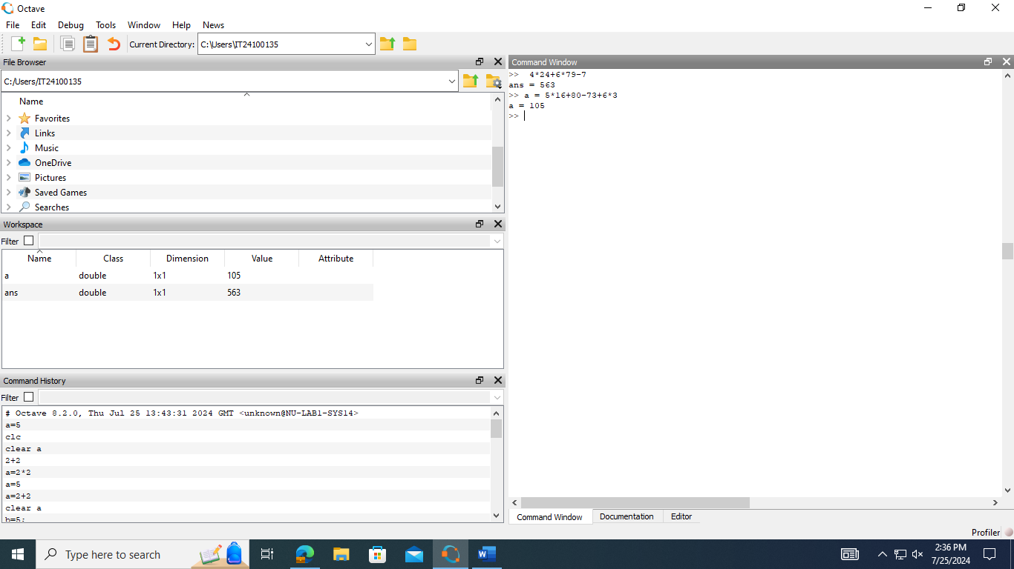

Q4)

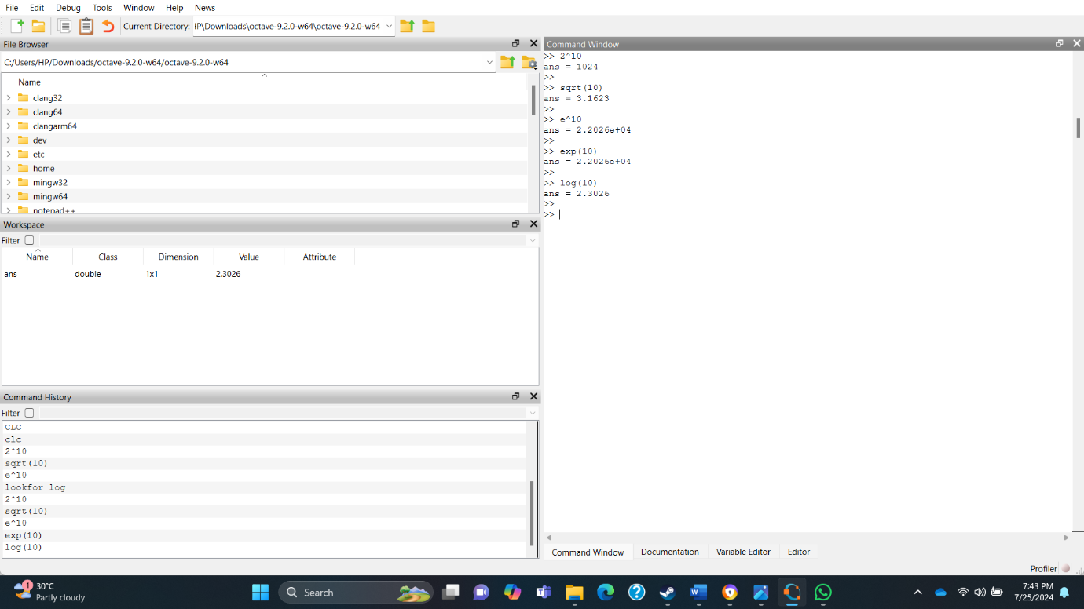

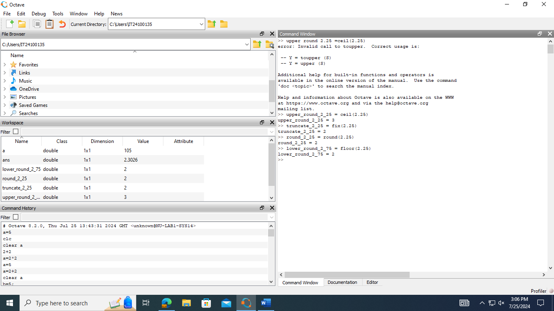

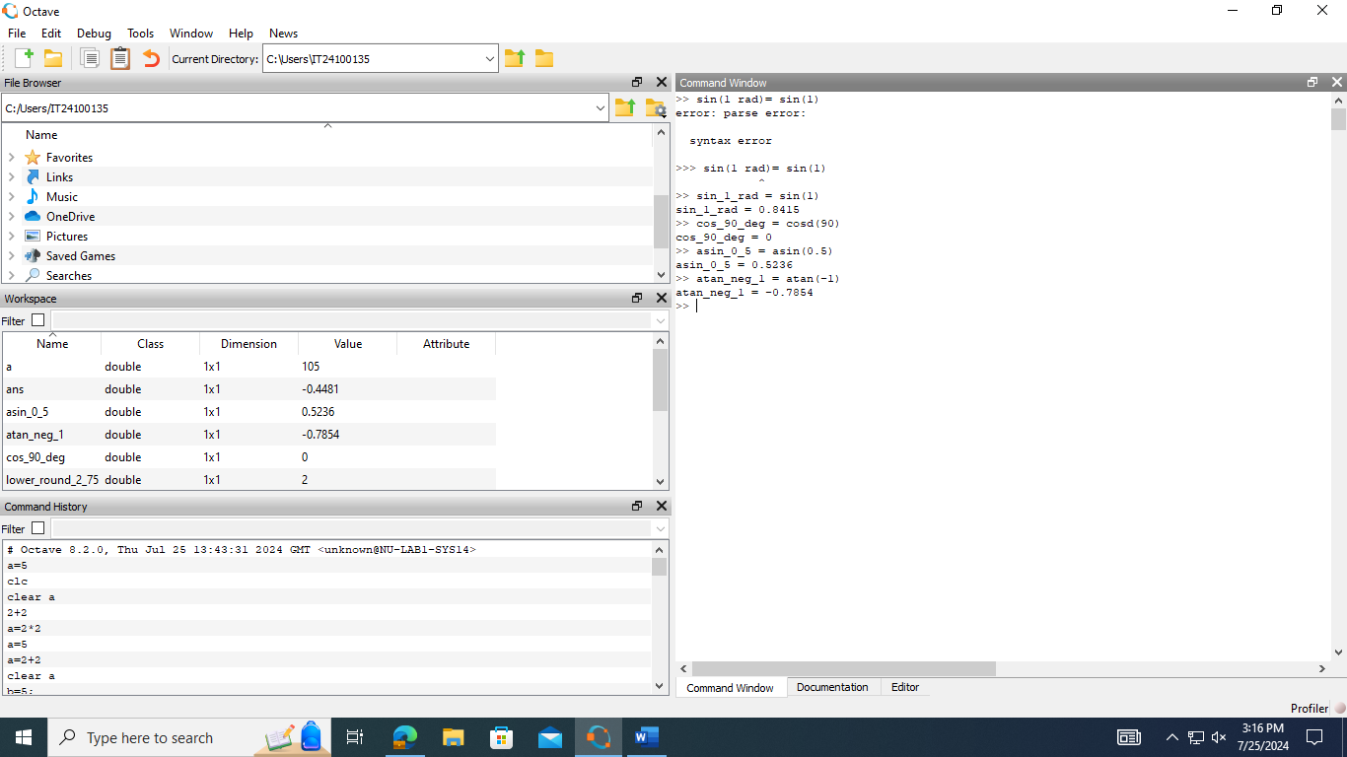

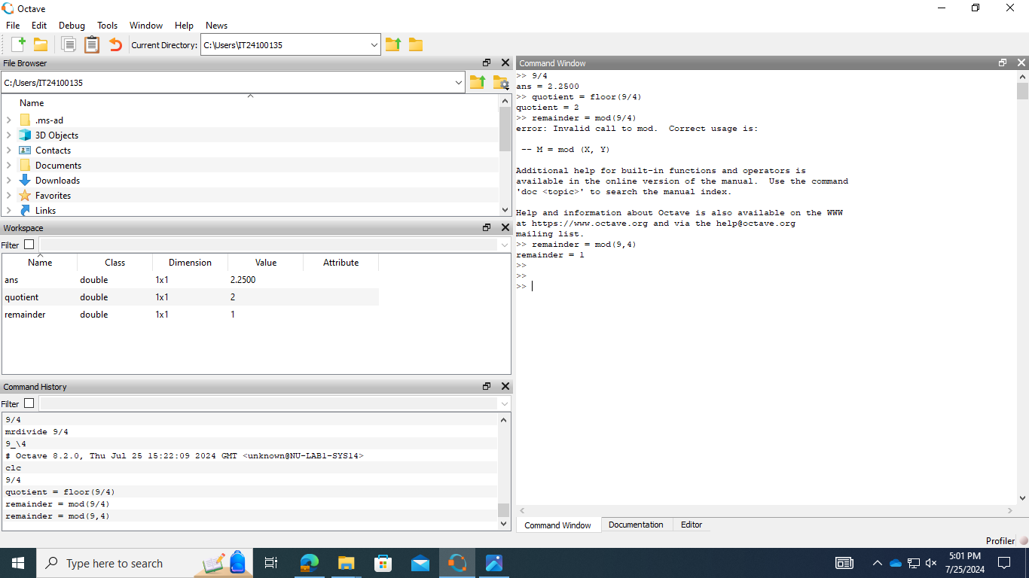

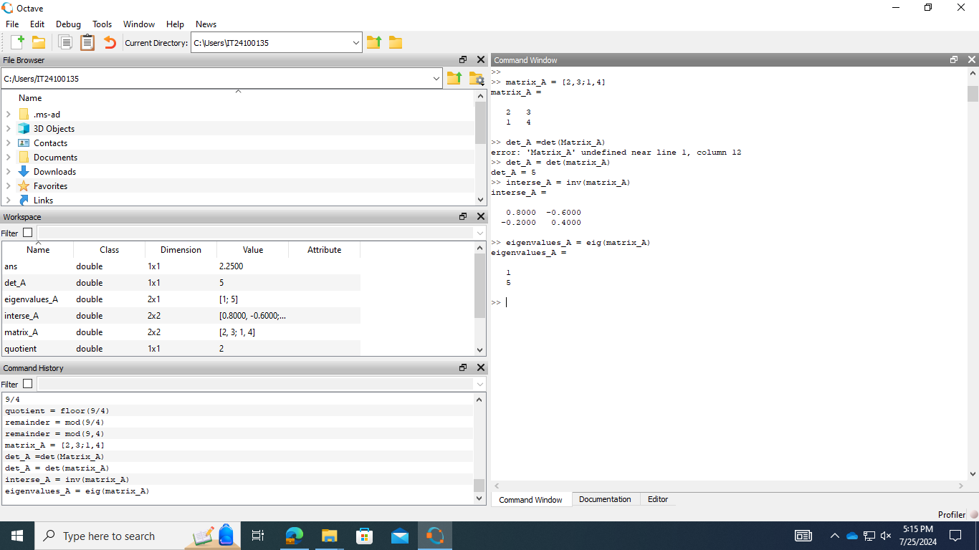

Q6), Q7)

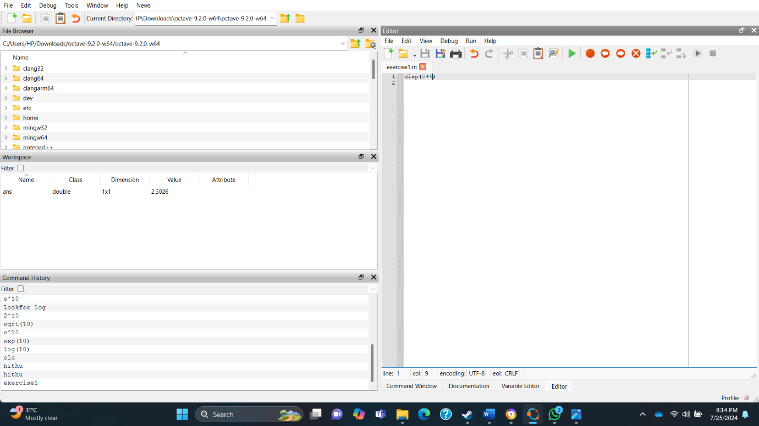

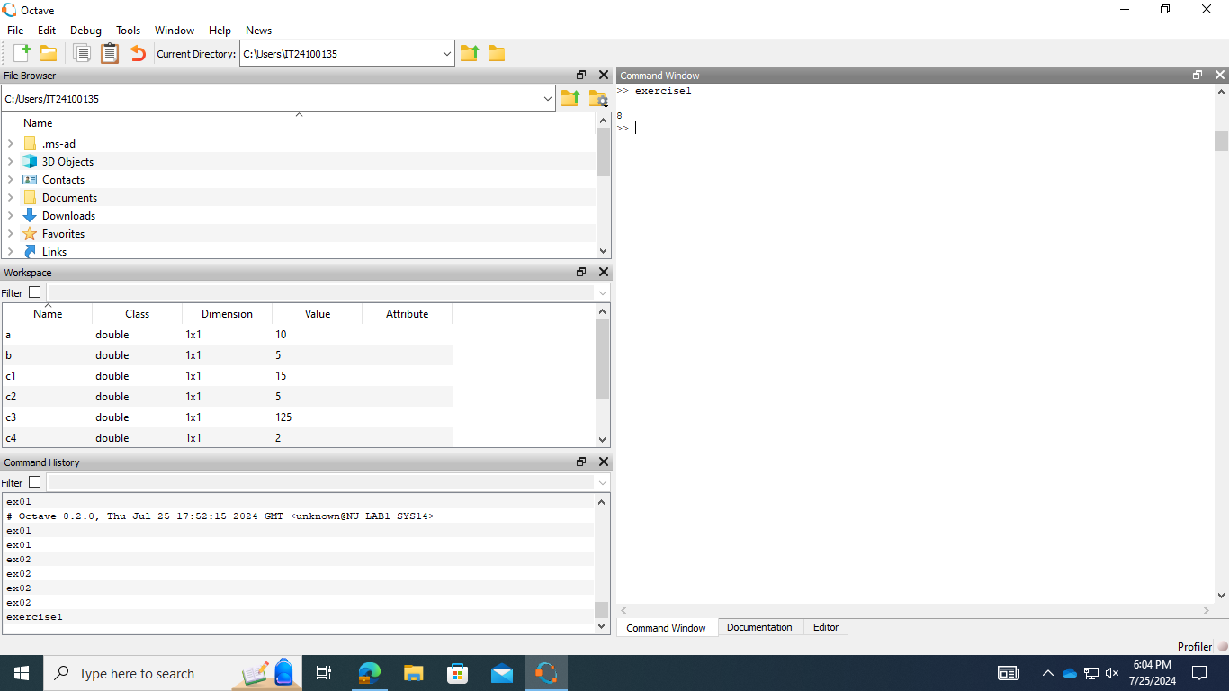

Q8)

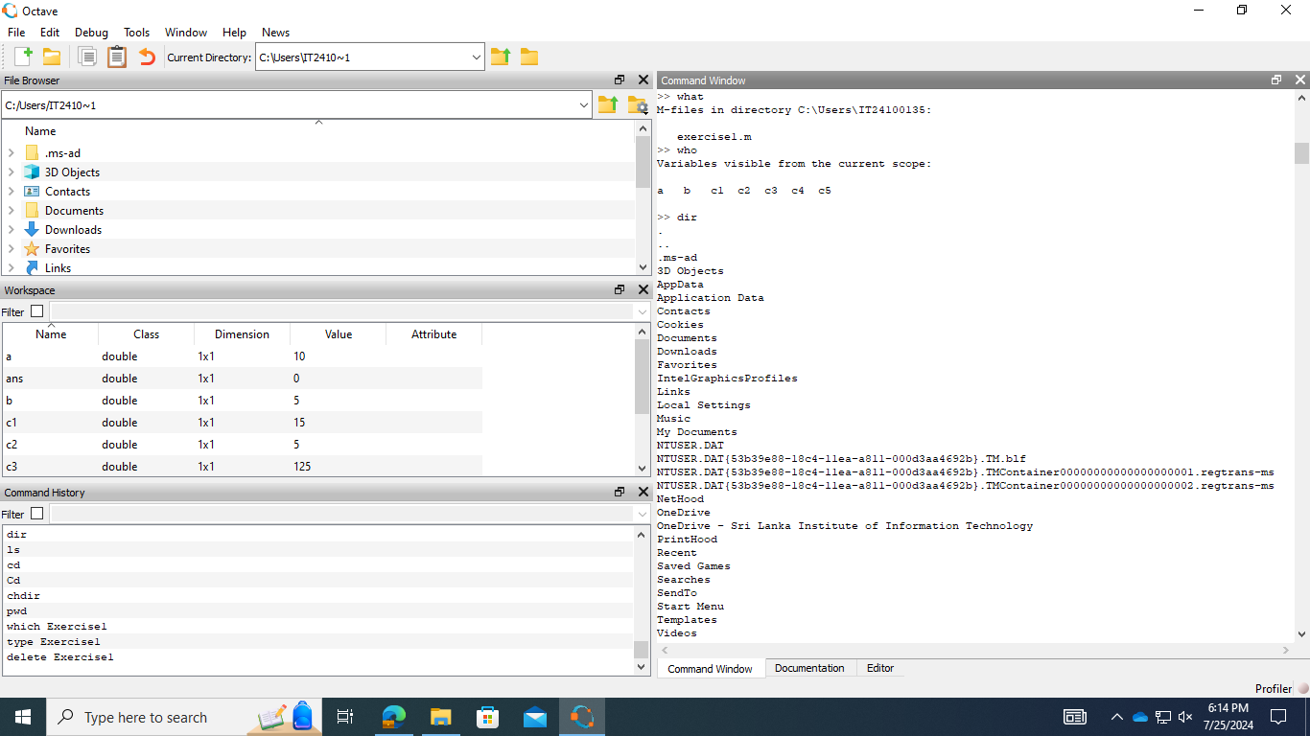

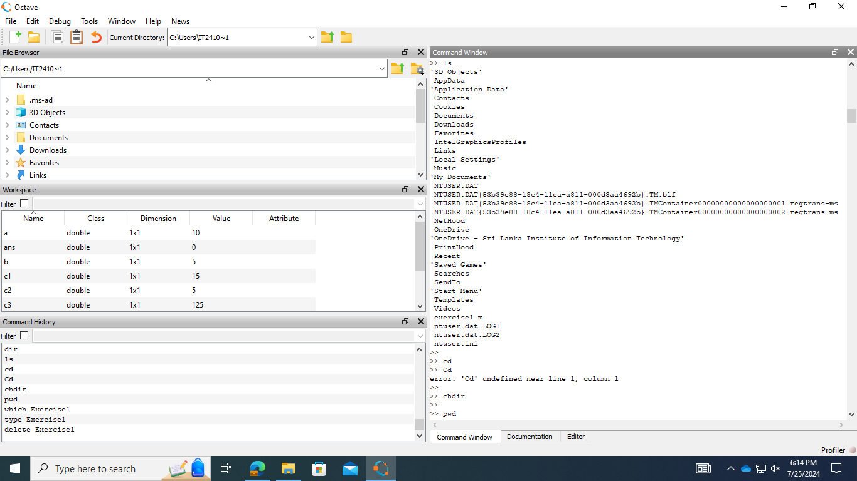

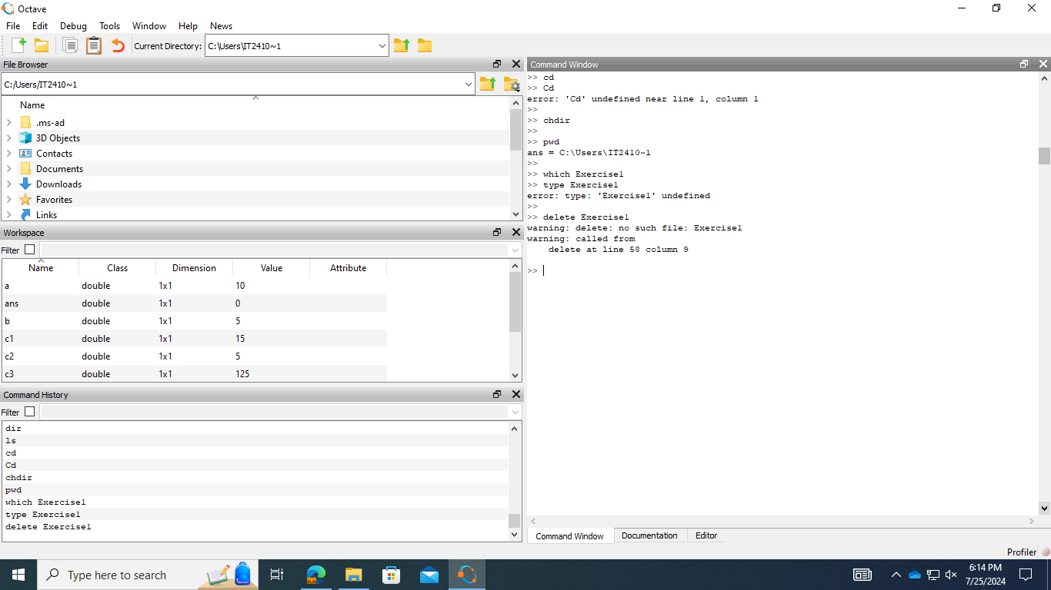

Exercise 2

Q1), Q2)

